★★☆☆☆
題組：基礎48題
題號：Q130: Roman Roulette
整理者：鄭紹雄
學號：ACS105103
使用語言:C++
解題日期：2018年7月22日
題目:
The historian Flavius Josephus relates how, in the Romano-Jewish conflict of 67 A.D., the Romans took the town of Jotapata which he was commanding. Escaping, Jospehus found himself trapped in a cave with 40 companions. The Romans discovered his whereabouts and invited him to surrender, but his companions refused to allow him to do so. He therefore suggested that they kill each other, one by one, the order to be decided by lot. Tradition has it that the means for effecting the lot was to stand in a circle, and, beginning at some point, count round, every third person being killed in turn.
The sole survivor of this process was Josephus, who then surrendered to the Romans. Which begs the question: had Josephus previously practised quietly with 41 stones in a dark corner, or had he calculated mathematically that he should adopt the 31st position in order to survive?
Having read an account of this gruesome event you become obsessed with the fear that you will find yourself in a similar situation at some time in the future. In order to prepare yourself for such an eventuality you decide to write a program to run on your hand-held PC which will determine the position that the counting process should start in order to ensure that you will be the sole survivor.
In particular, your program should be able to handle the following variation of the processes described by Josephus. n > 0 people are initially arranged in a circle, facing inwards, and numbered from 1 to n. The numbering from 1 to n proceeds consecutively in a clockwise direction. Your allocated number is 1. Starting with person number i, counting starts in a clockwise direction, until we get to person number k (k > 0), who is promptly killed. We then proceed to count a further k people in a clockwise direction, starting with the person immediately to the left of the victim. The person number k so selected has the job of burying the victim, and then returning to the position in the circle that the
victim had previously occupied. Counting then proceeeds from the person to his immediate left, with the k-th person being killed, and so on, until only one person remains.
For example, when n = 5, and k = 2, and i = 1, the order of execution is 2, 5, 3, and 1. The survivor is 4.
Input
Your program must read input lines containing values for n and k (in that order. Input will be
terminated by a line containing values of ‘0’ for n and k.
Your program may assume a maximum of 100 people taking part in this event.
Output
For each input line output the number of the person with which the counting should begin in order to ensure that you are the sole survivor. For example, in the above case the safe starting position is 3.
Sample Input
5 2
1 5
0 0
Sample Output
3
1
問題描述：
西元67年，在羅馬和猶太人的衝突中，史學家 Josephus 和其他40個人被關在一個洞穴中。羅馬人知道 Josephus 的下落後希望他能投效羅馬帝國。但是他的同伴們卻不允許他投降。所以Josephus 建議他們彼此殺害，一個接一個，被殺的順序就由命運決定。傳統上他們決定命運的方式為：大家圍成一個圓圈，從某個人開始算起，每算到 3 個人那個人就被殺掉，如此不斷下去，直到只剩一個人。後來 Josephus 成為唯一的存活者並投降羅馬。我們有興趣的是：Josephus 如何剛好是那個存活者？真的是運氣好，還是他事先在暗地裡用 41 顆石頭練習過，或者他有一個數學的方法可以知道要站在哪一個位置才能成為最後的存活者？
聽過這個故事後，你相當的憂心要是將來某一天你也面臨同樣的情況要怎麼辦。所以你決定用你的手上型電腦寫一個程式算出應該從那個人開始算起，你才可以成為那個最後唯一存活的人。
在這個問題中，你的程式必須能解決 Josephus 描述的另一種變形。有 n 個人排成一個圓圈，面向內，依順時鐘方向編號從 1 到 n。你的位置在 1 。殺人程序由編號 i 的人開始算起（順時鐘方向），直到算到第 k 個人，那個人立刻被殺掉。然後從這個被殺的人左邊的那個人再順時鐘方向算 k 個人，那個人必須負責埋葬剛才被殺的那個人，然後回去站在剛才被殺的那個人的位置。接下來從這個人的左邊那個人算起，第 k 個人又被殺掉，如此一直下去直到只剩下一個人為止。
例如：當 n=5, k=2, i=1, 那麼被殺的順序為 2, 5, 3, 1，存活者為4。

Input
輸入含有多組測試資料。
每組測試資料有2個整數 n, k 。你可以假設最多只有 100 個人。
若 n = k = 0 時代表輸入結束。請參考Sample Input。

Output
對每組測試資料輸出一開始時應該從哪一個人算起（也就是 i），才能確保你是最後唯一的存活者。請記住：你的位置在 1。以上述的例子來看，必須由第 3 個人算起，最後存活的人才能是 1 。

Sample Input
1 1
1 5
5 2
5 4
7 3
100 53
100 2
11 93
0 0
Sample Output
1
1
3
5
1
13
83
2
解法：
必須推導一次才知道其邏輯
會先假設從第一個數，然後算出哪一個位置不會死掉
然後往回推算出從哪一個開始數讓第一個位置不會死亡
即為所求

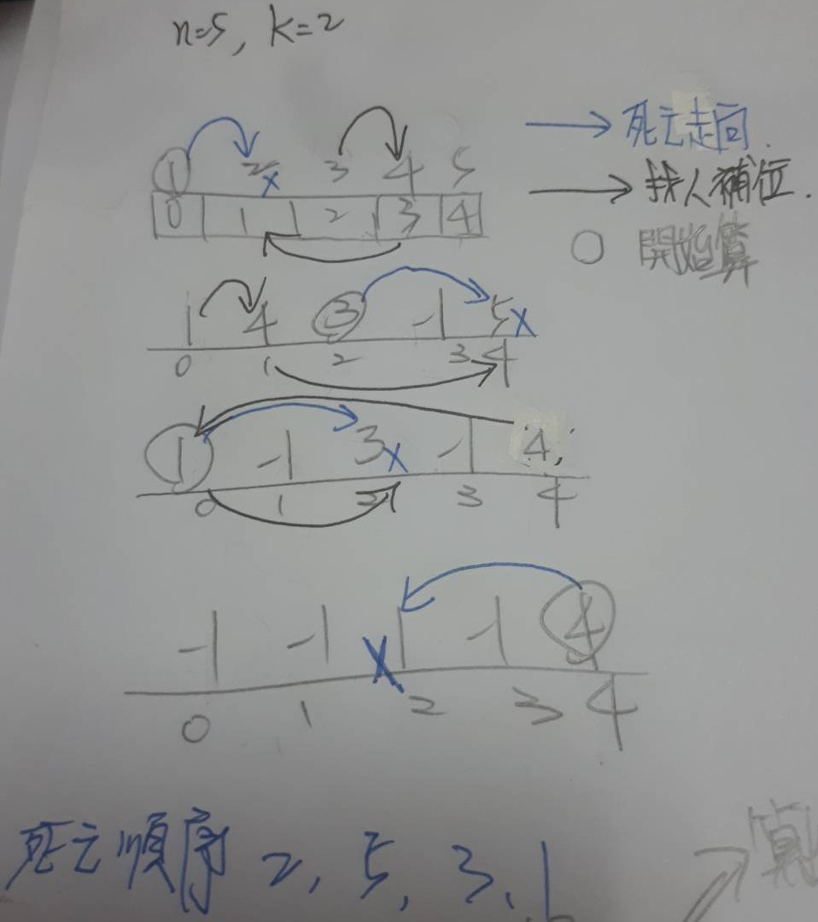
解法範例：
- 進行輸入n,k
- 由n,k初始化位置
- 假設從1開始走，
- 往左邊數k個位置(包含1)，那個位置死亡
- 死亡的那個位置的左邊在數k個位置(包含自己)，那個位置來補死亡的位置，原本自己的位置補-1
- 假如遇到-1的位置，那就在往下數一格
- 假如不是剩一個人的話，從補位的左邊一位開始數，回到3。
討論：
- 此題重複性高，所以創建函數進行重複呼叫
countPosition:計算k步之後會數到誰
counterPositionValue:協助countPosition不要數到-1
程式
#include<iostream>
#include<vector>
using namespace std;

int countPosition(int,int,vector<int>);
int counterPositionValue(int&,vector<int>);
int main(){
int n,k;
//輸入值
while(cin>>n>>k){
if(n==0||k==0){
break;
}
int position=0;
vector<int>people;
people.assign(n,0);
for(int i=1;i<=n;i++){
people[i-1]=i;
}

int die;
try{
for(int i=0;i<people.size();i++){

int reposition=-1;
position=countPosition(position,k,people);
reposition=position;
// cout<<"被淘汰的人:"<<people[position]<<endl;
die=people[position];
people[position]=-1;
position=countPosition(position,k+1,people);
//假如都為-1就丟出最後死亡那位
if(position==-2){
throw die;
}
//cout<<"幫忙埋葬的人"<<people[position]<<" 位置"<<position<<endl;
people[reposition]=people[position];
people[position]=-1;
position=reposition;
position=countPosition(position,2,people);
//cout<<"下一個開始的人"<<people[position]<<endl;
//cout<<endl;
}
}

}
//走幾count步 傳回值
int countPosition(int position,int count,vector<int> people){
//第一次的變數
int first=0;

for(int i=1;i<count;i++){
int countX=0;
//判斷下一個是不是-1
while(1){
//整個people裡面都是-1
if(countX==people.size()){
return -2;
}
//假如是-1就繼續找
if(counterPositionValue(position,people)==-1){
countX++;
continue;
}

break;

}

}
return position;

}
//幫忙數到不是-1的位置
int counterPositionValue(int& position,vector<int>people){

position++;
if(position==people.size()){
position-=people.size();
}

return people[position];

}
catch(int die){
if(n==1){
cout<<"1"<<endl;
}else{
cout<<(people.size()+1-die)%people.size()+1<<endl;
}

}

}

}
//走幾count步 傳回值
int countPosition(int position,int count,vector<int> people){
//第一次的變數
int first=0;

for(int i=1;i<count;i++){
int countX=0;
//判斷下一個是不是-1
while(1){
//整個people裡面都是-1
if(countX==people.size()){
return -2;
}
//假如是-1就繼續找
if(counterPositionValue(position,people)==-1){
countX++;
continue;
}

break;

}

}
return position;

}

//幫忙數到不是-1的位置
int counterPositionValue(int& position,vector<int>people){

position++;
if(position==people.size()){
position-=people.size();
}

return people[position];

}

